MS-F-1
Red light/Infrared therapeutic equipment

User manual

(Date modified:5th August 2016)
Beijing Kedixin Biotechnology Development Center

Contents

1、 Introduction....................................….................................................................P₂

2、Installation and direction for use.........................................................................P₄

3、 Product maintenance............................................................................................P₆

4、 Disinfection for product................................................................... ...................P₆

Appendix: Warranty card for red light/Infrared therapeutic equipment

The Packing list of red light/Infrared therapeutic device

- Instruction

1、Product name: Red light/Infrared therapeutic equipment
2、Registration number：(Beijing)20152260595。
3、Technical requirement number：(Beijing)20152260595。
The enterprise license number of medical device manufacture:(Beijing)20020003
4、 Main structure of product：Host and treatment heat；
5、Performance Index：
Input voltage：AC220V 、50HZ；
Input Power：250VA；
Volume：320×430×780mm；
Weight：23kg；
Security classification：Ⅰ B
The range of spectrum：0.8～3.0μm；
Voltage range of treatment head：5V~15Vcontinuously to be adjusted, tolerance±10%.
Output power： ≥3W；
Spot diameter：at 100mm from optical spot, the diameter is not less than 120mm.
Fuse: F3.15AL250V

Indication：
1、Relieve pain from leukoplakia of vulva，cervical erosion，colpitis, condyloma acuminatum；
2、Diseases, such as wound infection, nonunion wound, ulcerous wound, hyperplasia of mammary glands, and bedsore, could be healed.
3、Relieve pain of acute and chronic rhinitis, oral ulcer, and herpes simplex of mouth.
4、This device could help to relieve pain in eczema, neurodermatitis, herpes zoster.
5、Relieve lumbocrural pain, scapulohumeral periarthritis and arthritis.

Contraindication：
- Patients with artery occlusion in limbs and bleeding tendency.
- People with eye or auditory meatus disease.
- Angiocardiopathy patients are not allowed to treat in high-power and treatment for long periods of time.
d. Patients with bleeding tendency, hyperpyrexia, active tuberculosis, and malignant tumor
Matters need attention：
Doctor need to wear sunglasses for protection during treatment with high-intensity output.

Tips：
a. Fresh scar should not be accepted treatment.
b. Please do not look at treatment head directly.
c.The light intensity of treatment head is adjusted following doctors advice, or depending on patients lesions to light sensitivity or tolerance. Do not overheat, prevent to be burn.

Need to be noticed：
- During treatment, please follow the manual operation steps, and do not exposure another part except nidus.
- The power supply must to be fixed, and ground wire needs to be installed for good.

2、 Installation and direction for use
MS-F-1 Red light/Infrared therapeutic equipment belong to mechanical and electronic integration device, made of host and treatment heat.
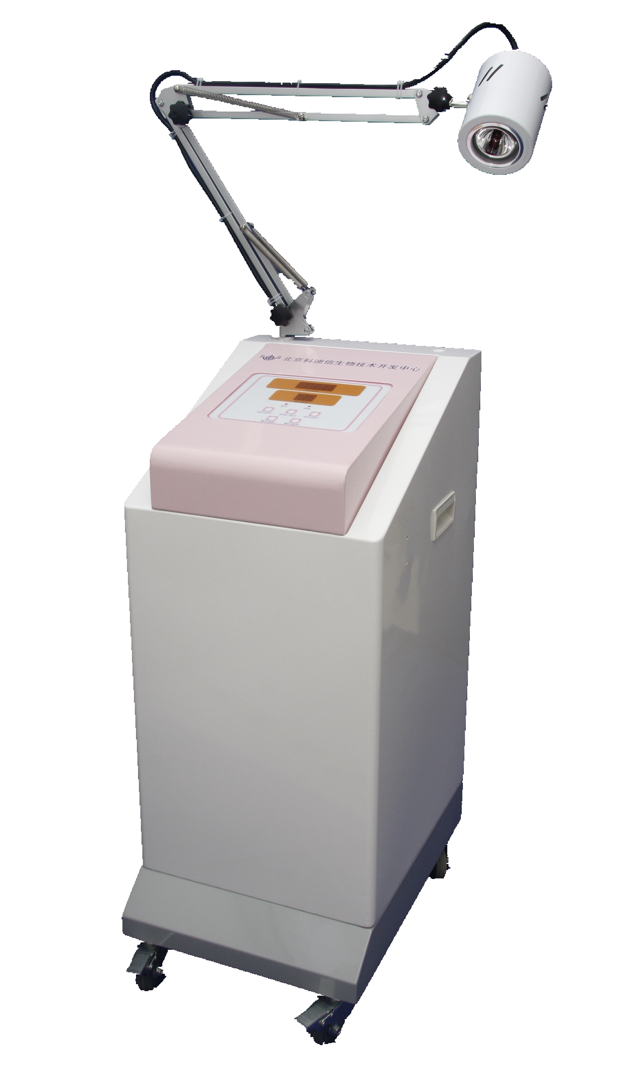
Support Arm
Treatment head
Control panel
Host
Operation steps：
    - Firstly, turn on Switch.
    - Adjust support，put treatment heat to the right place, then set the heat face to disease part, make distance almost 10cm , please pay attention that treatment heat does not allow to touch disease parts to prevent burns.
    - Time button +/-, is used to adjust treatment time.
    - The button +/- of intensity is used to adjust output intensity. In order to avoid to be burned at turning on, please do not use too high-intensity during treatment.
5、Press start/stop button, device gets into functional mode, and activates countdown-timer. At this time, output intensity could be adjusted to optimum condition. During countdown, timer is out of able to be adjust.
6、After the timer is done , the buzzer beeps. And turn off the power automatically, then back to standby mode.
7、This device outputs calorescence, light intensity of output could be adjusted, but need to follow doctors advice, or depend on patients lesions to light sensitivity or tolerance. Do not overheat, prevent to be burn.
8、At last, turn off the power.
9、The default therapy time of this device is 30 mins, users also can adjust it regarding actual conditions as follow:
- Turn off the power, switch on the back panel；
- Before connecting power ,press the button “therapy timing-”and “therapy timing+” at the same time, then turn on the power switch, after heard the warning sound of buzzer, release the buttons. Now the signal lamp of stand-by and therapy shines together which means it’s already for setting default therapy time.
- By pressing the buttons of “therapy timing-”and “therapy timing+” to select the time you want ,then press “start/stop” to finish adjusting. After this adjustment, it will appear new therapy time when the device starts up or holding state back from therapy state. If you want to cancel the adjustment ,please press “output intensity -”or “output intensity +”.
10、The default output intensity of this device is 40%, users also can adjust it regarding actual conditions as follow:
- Turn off the power switch on the back panel；
- Press the button of “output intensity -”or “output intensity +”together, then turn on the power switch, after heard the warning sound of buzzer, release the buttons. Now the signal lamp of stand-by and therapy shines together which means it’s already for setting default output intensity.
- By pressing the buttons of “output intensity -”or “output intensity +” to select the time you want ,then press “start/stop” to finish adjusting. After this adjustment, it will appear new therapy time when the device starts up or holding state back from therapy state. if you want to cancel the adjustment ,please press “therapy timing-”or “therapy timing+”.

Chapter 3． Daily maintenance

1、Only for professional person’s using and taking care, In case of dust 、falling and damp.
2、If this device doesn’t work ,please do self-inspection first as follow :
Power failure
1、please check whether the plug of power is connected well or not。
2、Check the fuse(Upper back panel).
Note :In case of electric shock, before changing fuse ,you have to disconnect the power plug ,then assemble the new F3.15AL250V fuse
3、Please contact manufacturer if it’s no use regarding above two methods.
3、Users can not change the light source of irradiation head by themselves, if the bulb is broken ,please send it back to the manufacturer for maintenance and replacement.
4、The bulb is demageble part which is not included in warranty for man-made damage.
5、Service life :5 years

Chapter 4 Clean and Disinfect

1、Clean and Disinfect of Irradiate head
Using clean duster cloth with 95% alcohol to scrub the surface of Irradiate head softly.
2、Clean and Disinfect of Main device
Using clean duster cloth until no dust or blot exists.

Red light/infrared light therapeutic apparatus Warranty card

Model： Serial Number： purchasing date： first line： Sent back to manufacturer after user completed
User name
Address
Postcode |  | Tel |  |  | Signature of receiver
S.N | Instrument failure |  |  | Replacement parts | Maintenance date | Signature of maintainer

Red light/infrared light therapeutic apparatusWarranty card

Model： Serial Number： purchasing date： Second line：User retention for maintenance.
User name
Address
Postcode |  | Tel |  |  | Signature of receiver
S.N | Instrument failure |  |  | Replacement parts | Maintenance date | Signature of maintainer

1. Follow 《user manual》2. One year warranty, lifetime maintenance. 3. Man-made damage or vulnerable parts (light bulb) is not included in the warranty. 4. The warranty of the light bulb lasts for 3 months.。

MS-F-1 Red light/infrared light therapeutic apparatus
Packing list

NO. | Name | quantity
1 | Main device | 1
2 | irradiation head（lampshade、lamp、holder） | 1
3 | Spare lamp（24V/50W） | 1
4 | Fuse F3.15AL250V | 2
5 | User manual | 1
6 | Warranty card | 1
7 | Certification | 1
8 | Power line | 1
9 | Safety goggle | 1
10 | Key | 1

Device name：Red light/infrared light therapeutic apparatus
Manufacturer ： Beijing Kedixin Biotechnology Development Center
Registration No.：Beijing FDA 20152260595。
Product technical requirements No.：Beijing FDA 20152260595。
Numbers of Production License：Beijing FDA No. 20020003
Aftersales service：Beijing Kedixin Biotechnology Development Center
Manufacture/Certificate Address： The second floor of Room 32 and 33,No. 408,Taizhouwu ,Haidian District,Beijing City
Postcode：100095
Tel：010-62467307 010-62464827
Aftersales service Tel:010-62575267
Fax ：010-62480116
Website ：www.kedixin.cn
E - MAIL：bjkdx@163.com

